# **Linux Commands Practice Questions -2**

## **File and Directory Operations**

1. How do you copy a file named "report.pdf" from your home directory to a folder called "documents"?

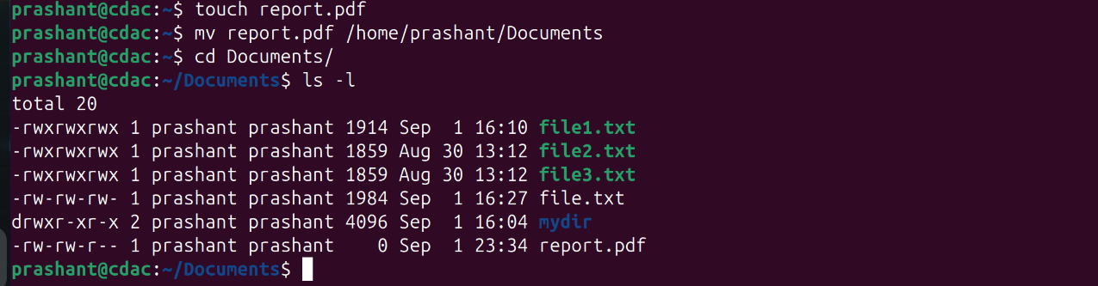

1. What is the difference between rmdir and rm -rf commands?

rmdir is used to remove a directory while rm -rf is used to forcefully remove a directory if it’s not empty.

1. How do you move a file named "data.csv" from the "downloads" folder to the "projects" folder?  
   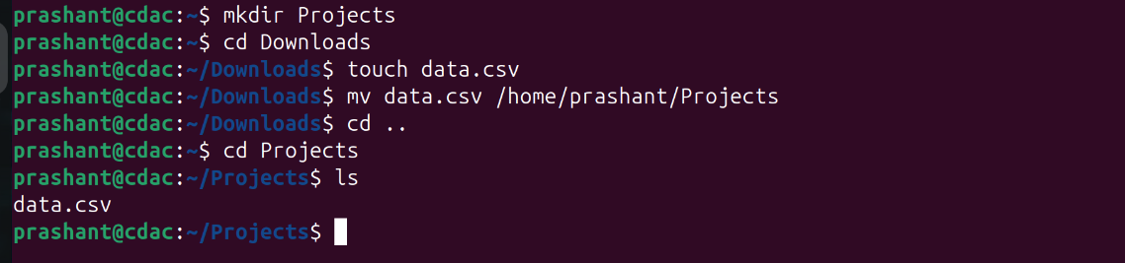
2. What command shows your current location in the file system?

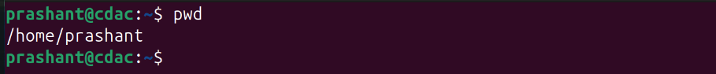

1. How do you create three empty files named "log1.txt", "log2.txt", and "log3.txt" simultaneously?

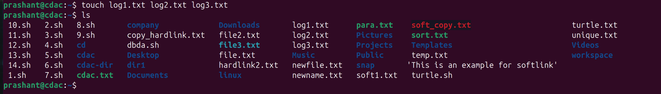

1. How do you change a directory name from "old_project" to "new_project"?

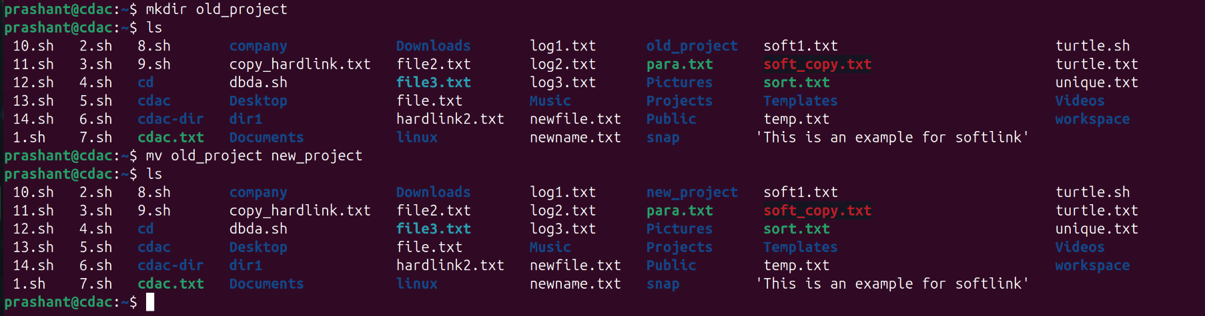

1. How do you delete a file named "temp.log" without any confirmation prompt?

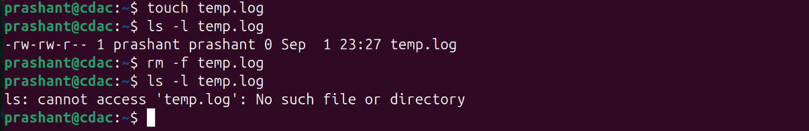

1. Display your current directory path using a command.



1. Show directory contents with file sizes in human-readable format (KB, MB, GB).

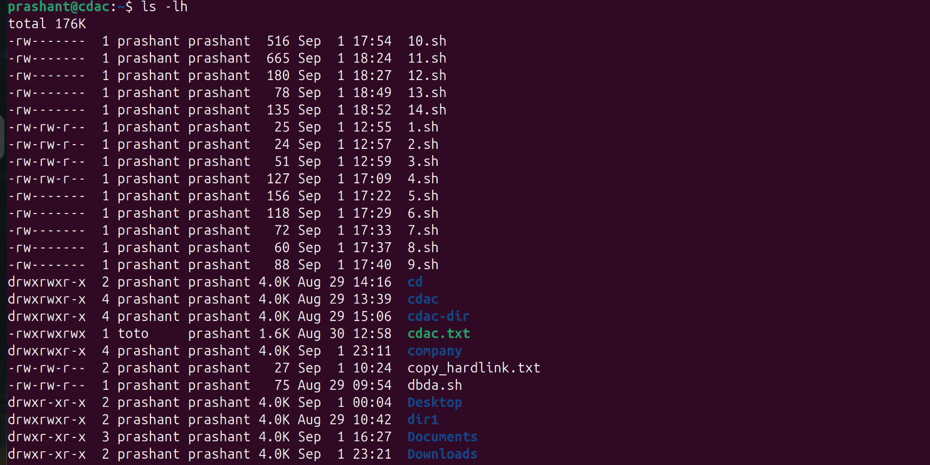

1. Explain the meaning of the first character in file permissions (d, -, l) when using ls -l.

**-** → **Regular file** (normal file like text, images, executables).

**d** → **Directory**.

**l** → **link** (pointing to another file/directory).

1. List all files including those starting with a dot (.) in the "/etc" directory.

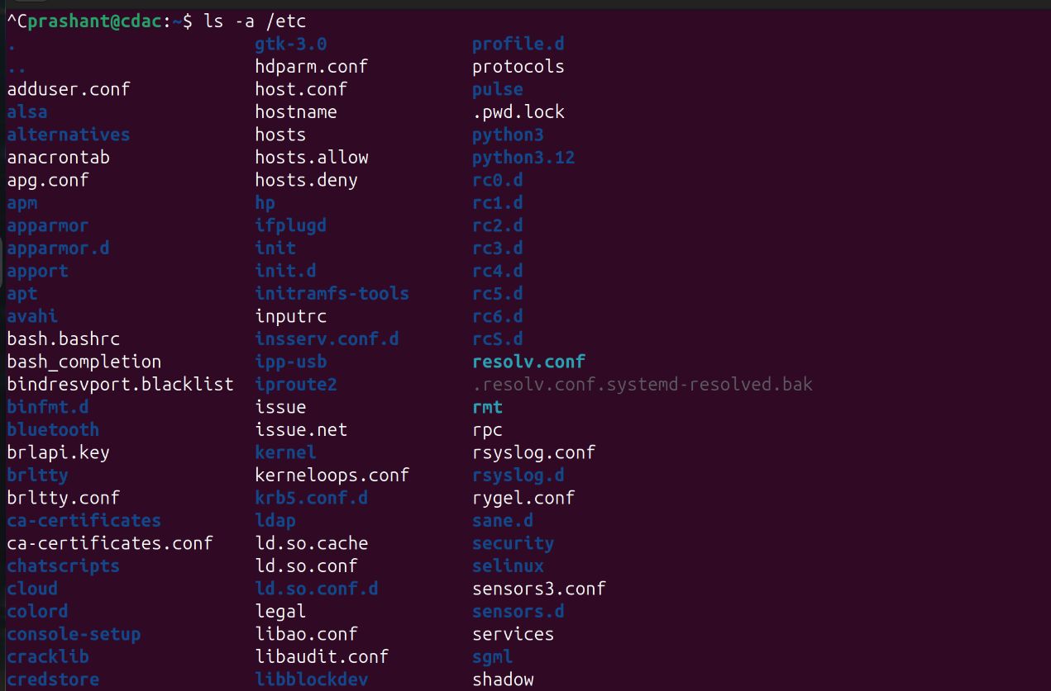

1. Show only files that start with a dot in your home directory.

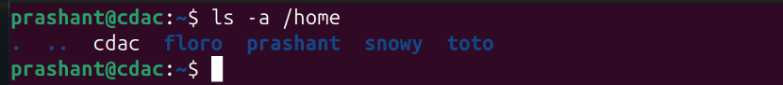

1. Create a directory structure "workspace/projects/web/frontend" in a single command.

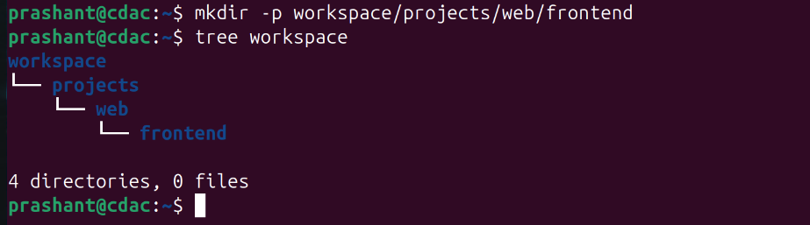

Create the following nested structure in one command:  
  
 company/

├── departments/

│ ├── hr/

│ ├── finance/

│ └── tech/

└── employees/

├── active/

└── former/

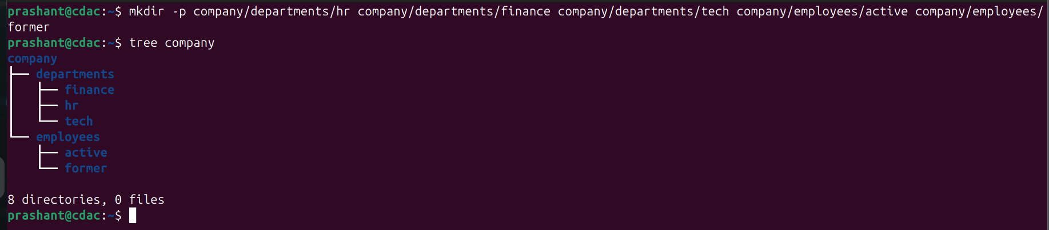

1. Create a directory named "test_dir", then remove it and verify it's gone.  
   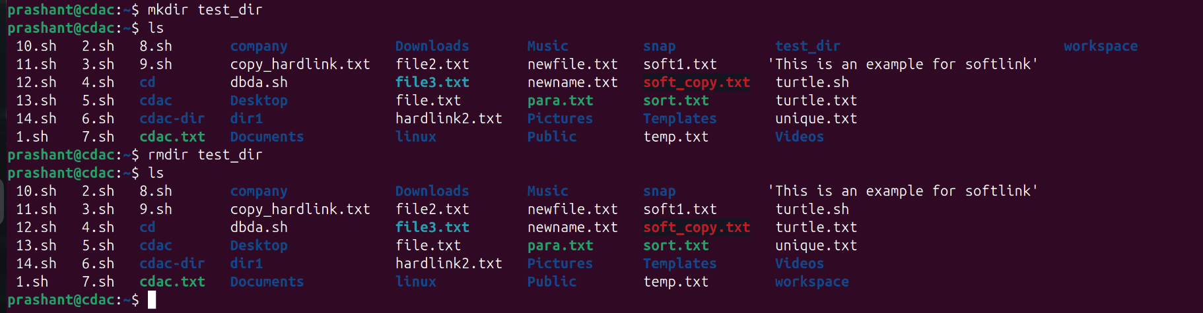

## **File Content and Text Processing**

1. Save the manual page of the find command to a file named "find_manual.txt".

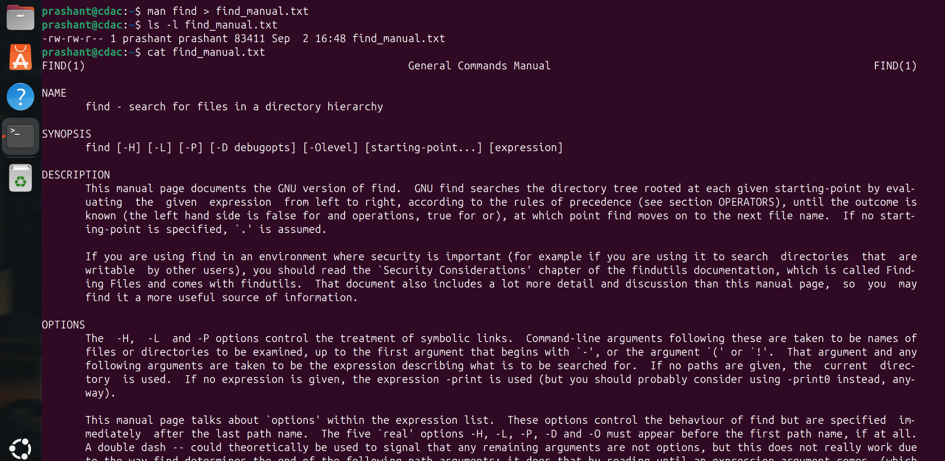

1. Display the first 15 lines and last 8 lines of "find_manual.txt".

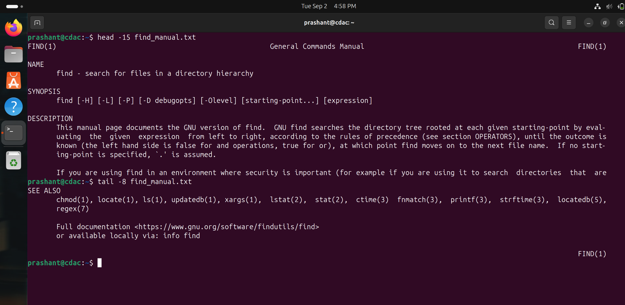

1. Copy "find_manual.txt" to a folder named "manuals" and rename the copy to "find_help.txt".

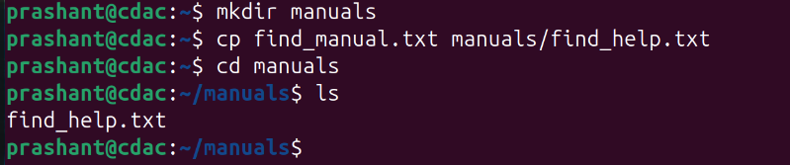

1. Count the total lines, words, and characters in "find_manual.txt".



1. Show your last 15 executed commands.

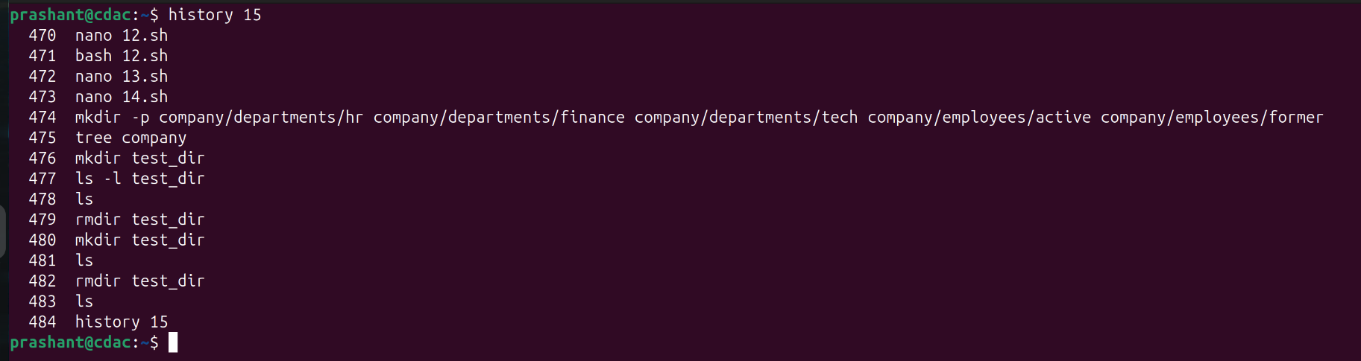

1. Create a tar.gz archive of your home directory's Documents folder.

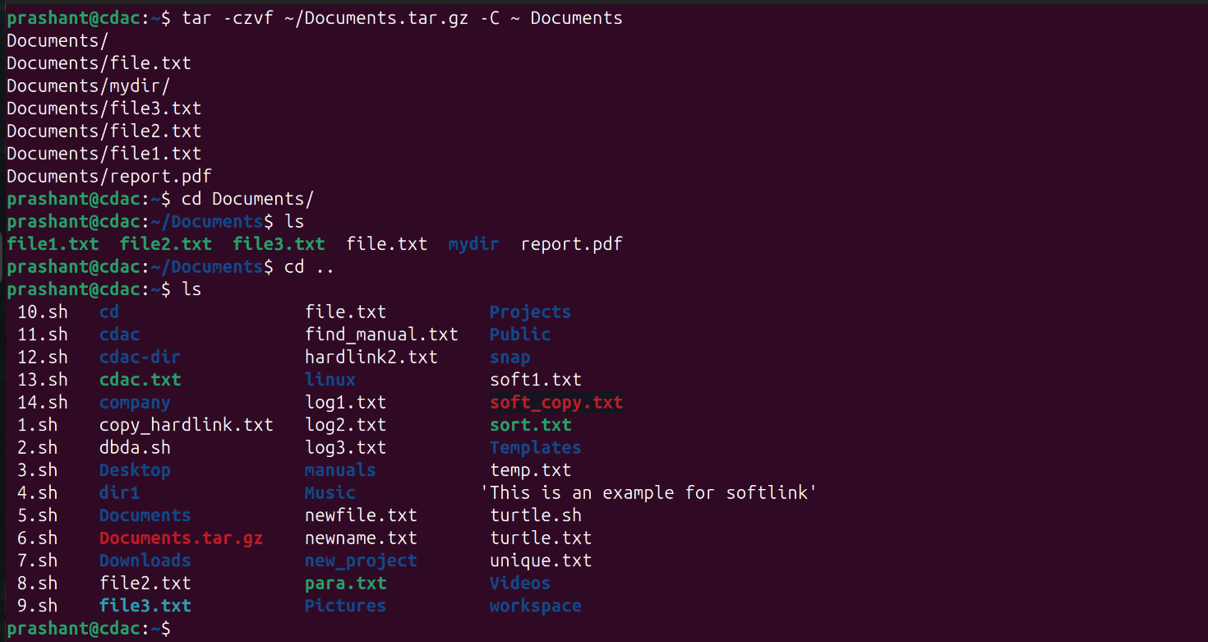

1. Create a zip archive of your Desktop folder and list its contents without extracting.

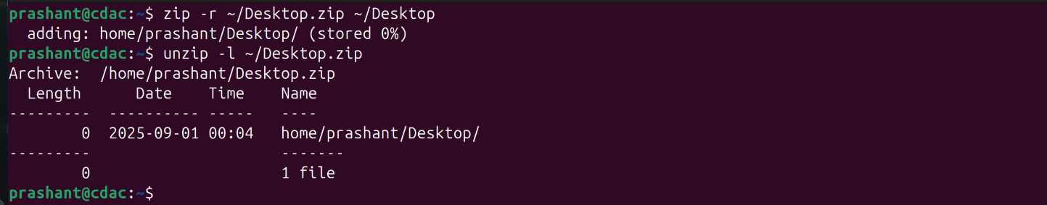

1. Set permissions for "script.sh" to be readable, writable, and executable by owner only.

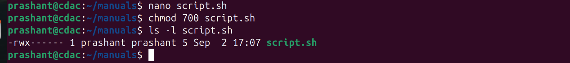

1. Change the owner of "database.txt" to user "admin".

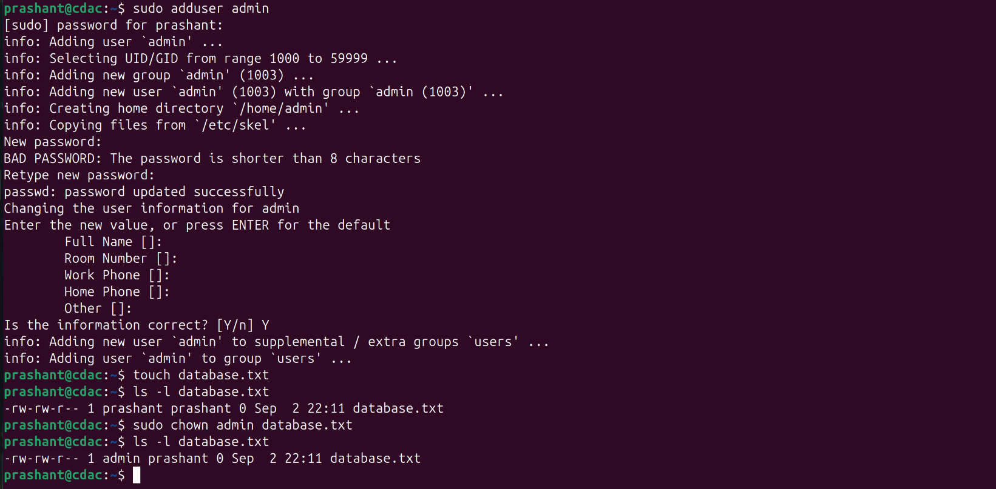

1. Display currently running processes in your terminal, all system processes, and sort processes by CPU usage.

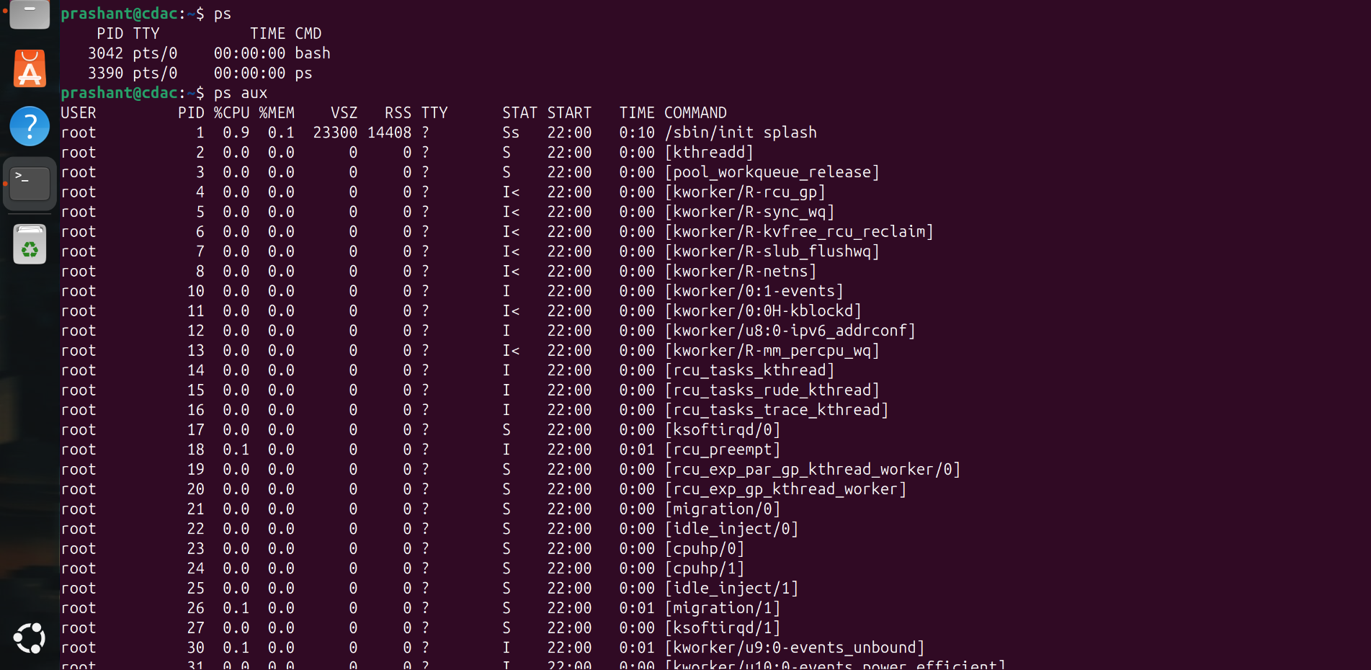

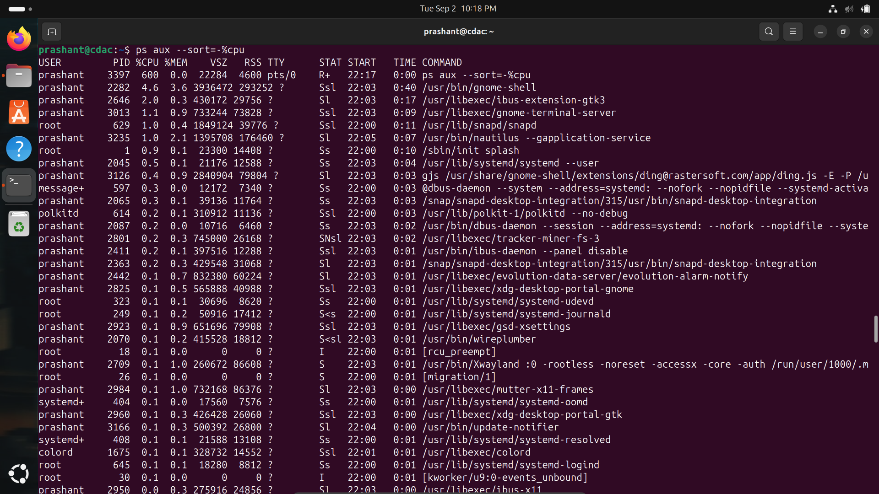

1. Show the current date/time and display the calendar for the current month.

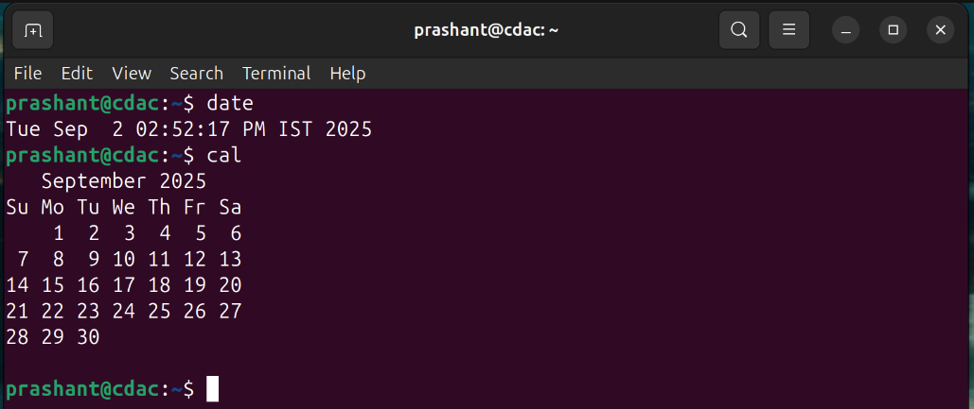

1. Set the system date to January 15th, 2025, 2:30 PM.

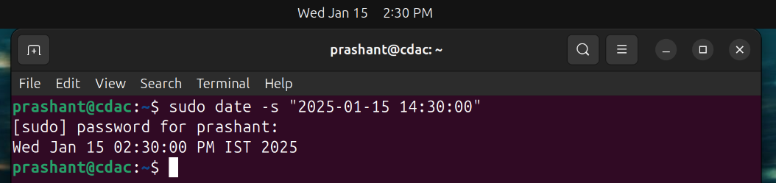

## **System Information Commands**

1. Research and explain these commands: uptime, df, du, free.
2. uptime: Shows how long the system has been running, how many users are logged in, and the system load.
3. df: Displays disk space usage of all mounted file systems.
4. du: Shows the disk space used by files and directories.
5. free: Displays the amount of free and used memory (RAM) on the system.

1. Create a directory "linux_lab", navigate into it, create "permissions_test.txt", check its default permissions, modify umask to 022, create "new_permissions_test.txt", and compare their permissions.  
   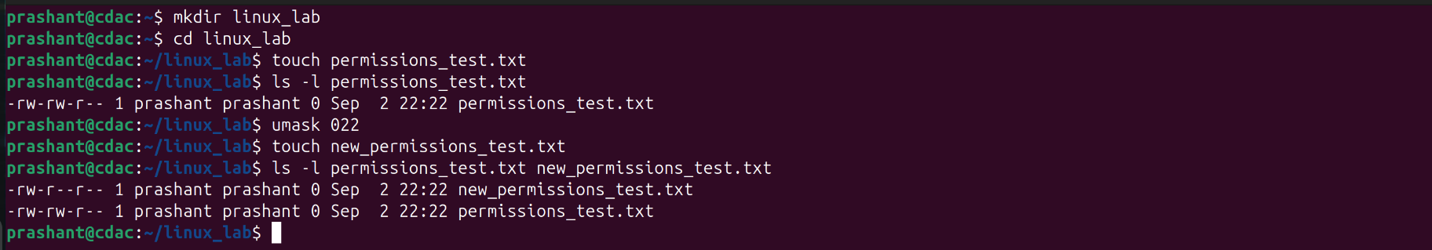
2. Create "original.txt" and make a hard link named "hard_copy.txt" pointing to it.

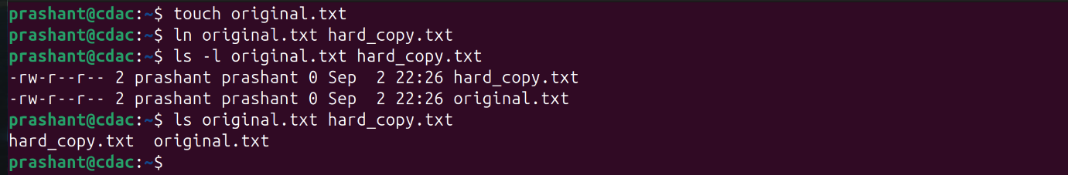

1. Create "source.txt" and make a symbolic link named "sym_link.txt" pointing to it.  
   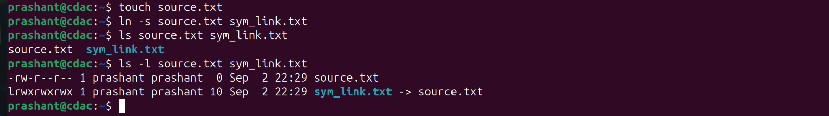
2. Copy the entire "projects" directory from a remote server to your local "Downloads" folder using SCP.
3. Download files from a public FTP server like ftp.gnu.org using command line FTP client.

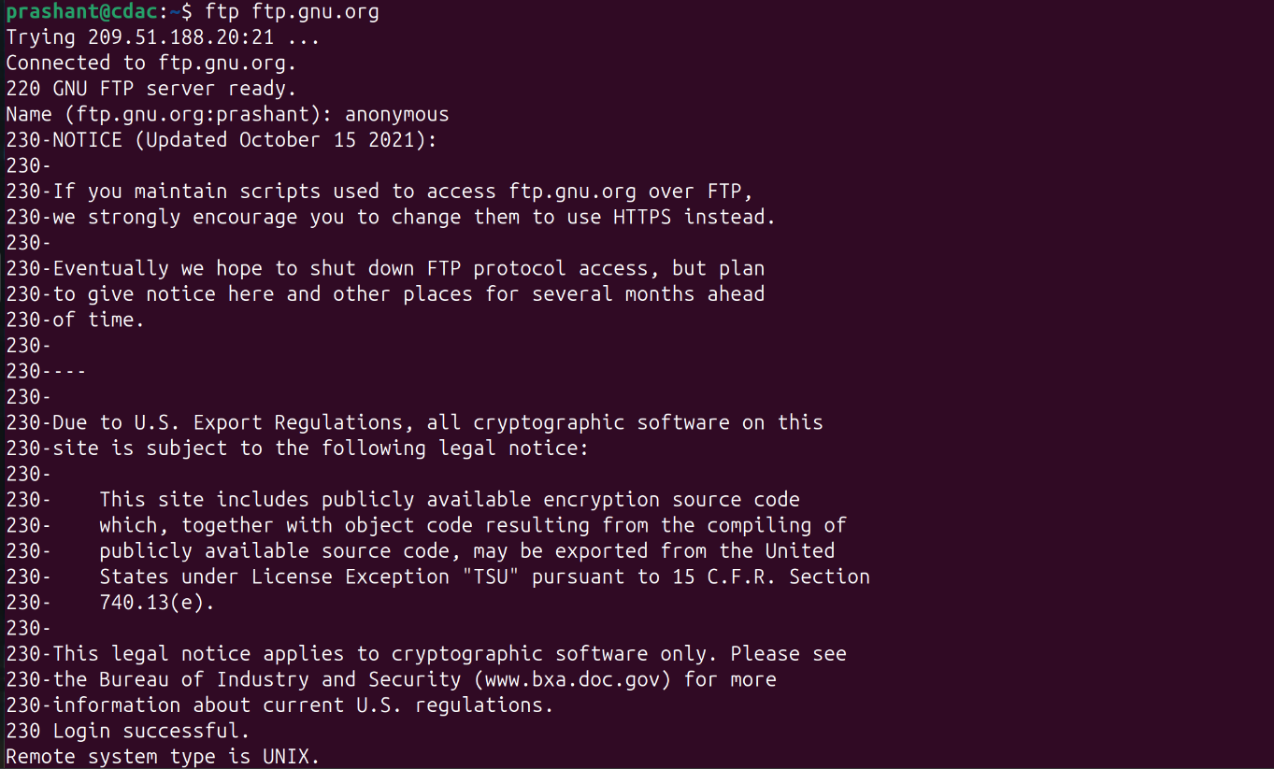

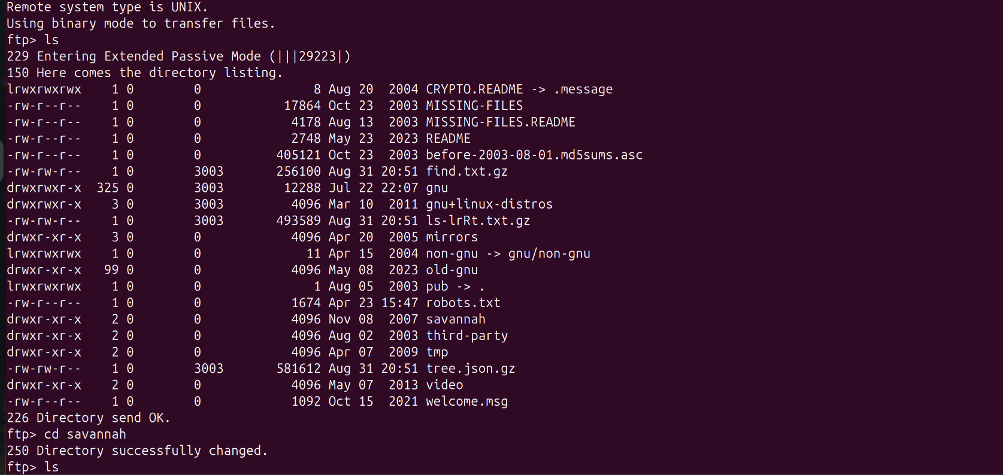

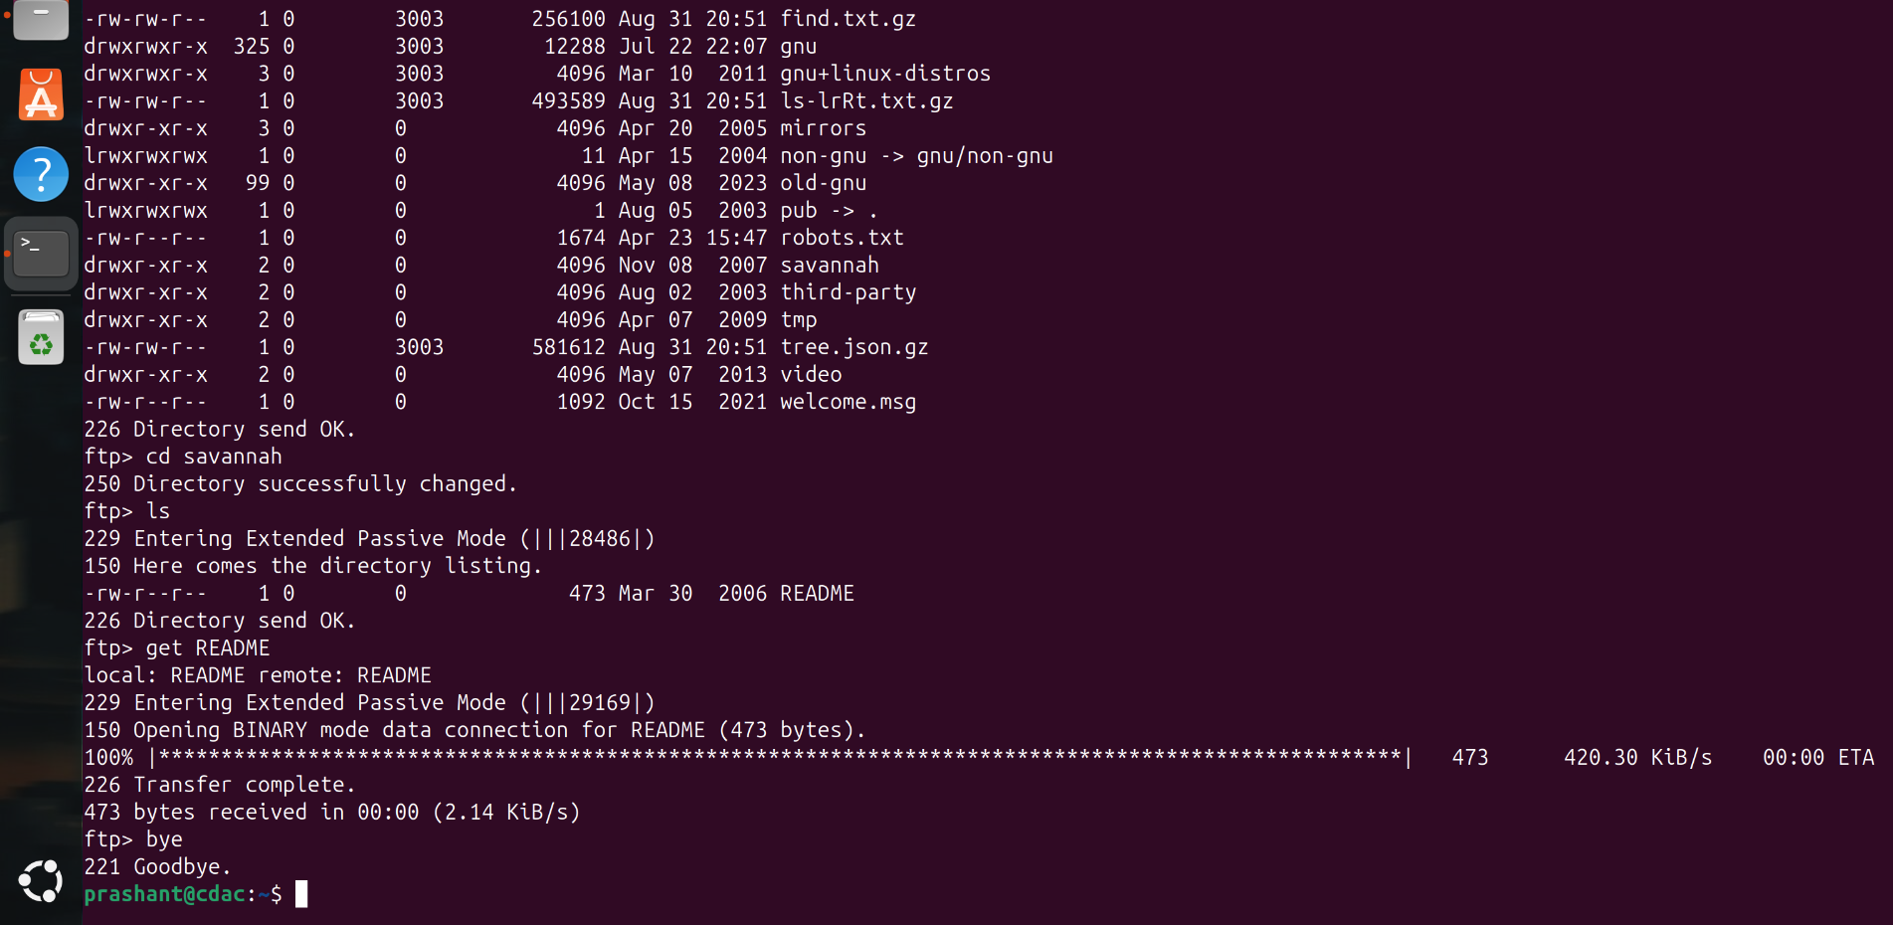

1. How do you remove a directory named "old_data" containing files and subdirectories?

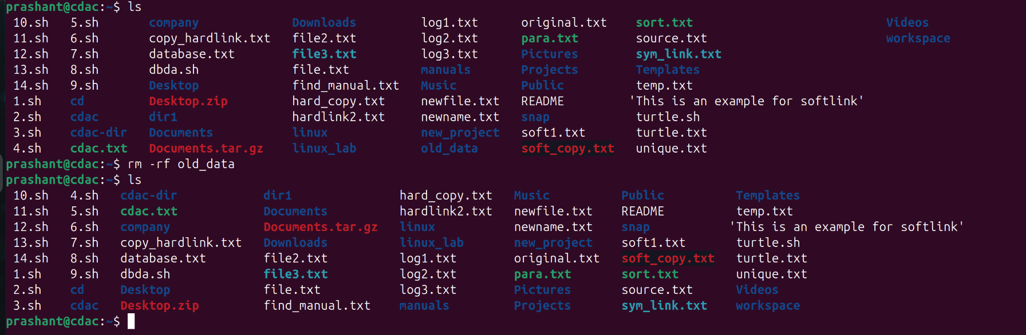

1. List all files in "/var/log" showing detailed information including hidden files.

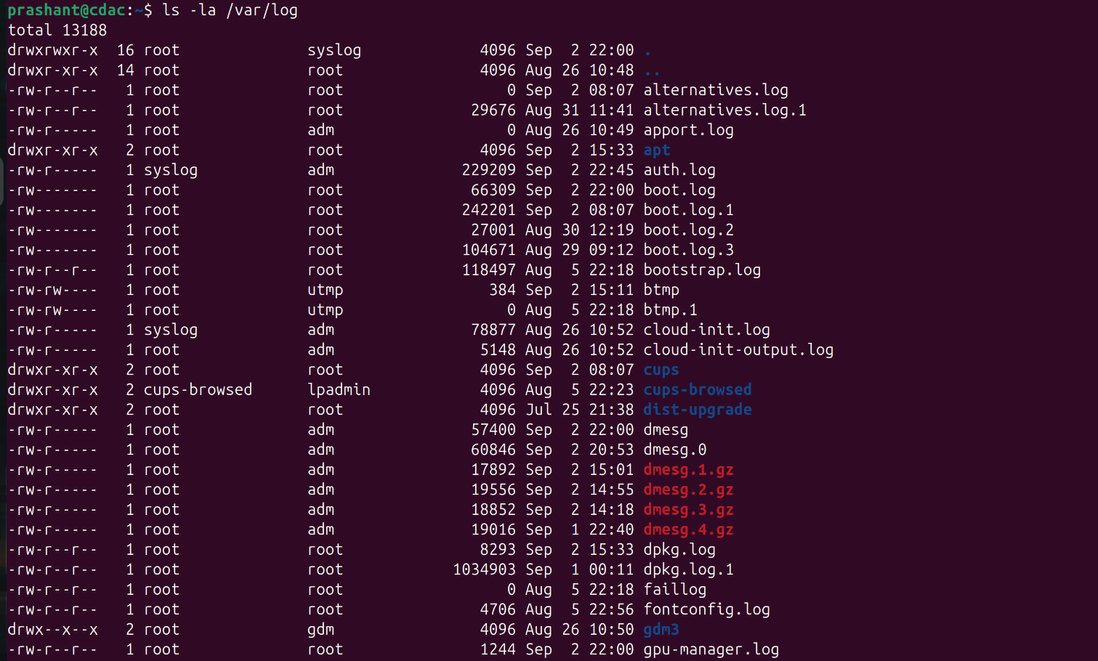

1. Create a file named "config.txt" in the path "/opt/myapp/config/" using command line.

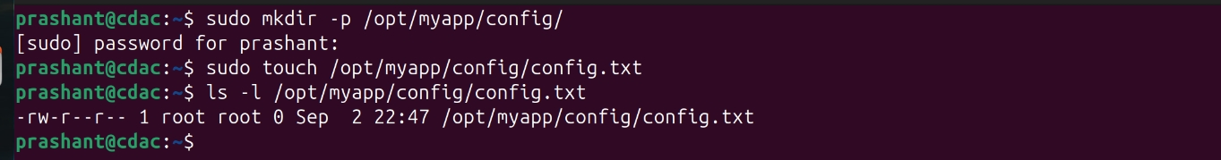

1. Search for the word "error" in all ".log" files within the current directory and subdirectories.



1. Create a directory "myproject" with permissions 755 (rwxr-xr-x).

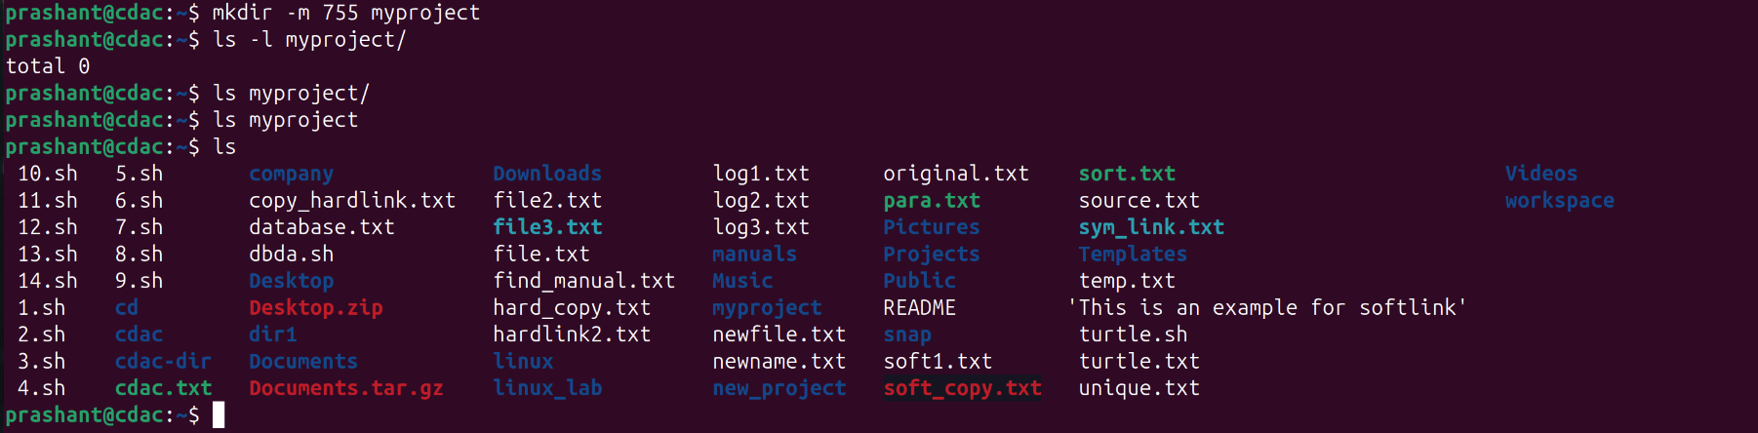

1. Create a compressed tar archive named "backup.tar.gz" containing all files and subdirectories in "/home/user/documents".

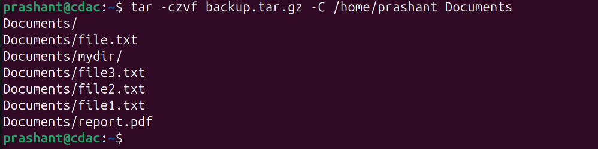

1. Give read and write permissions to owner and group, but only read permission to others for "shared.txt".

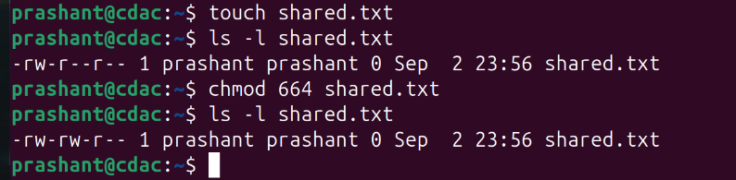

1. Find the size of "video.mp4" and display it in human-readable format (MB/GB).  
   
2. Find all files in "/home" and subdirectories that were modified in the last 7 days.

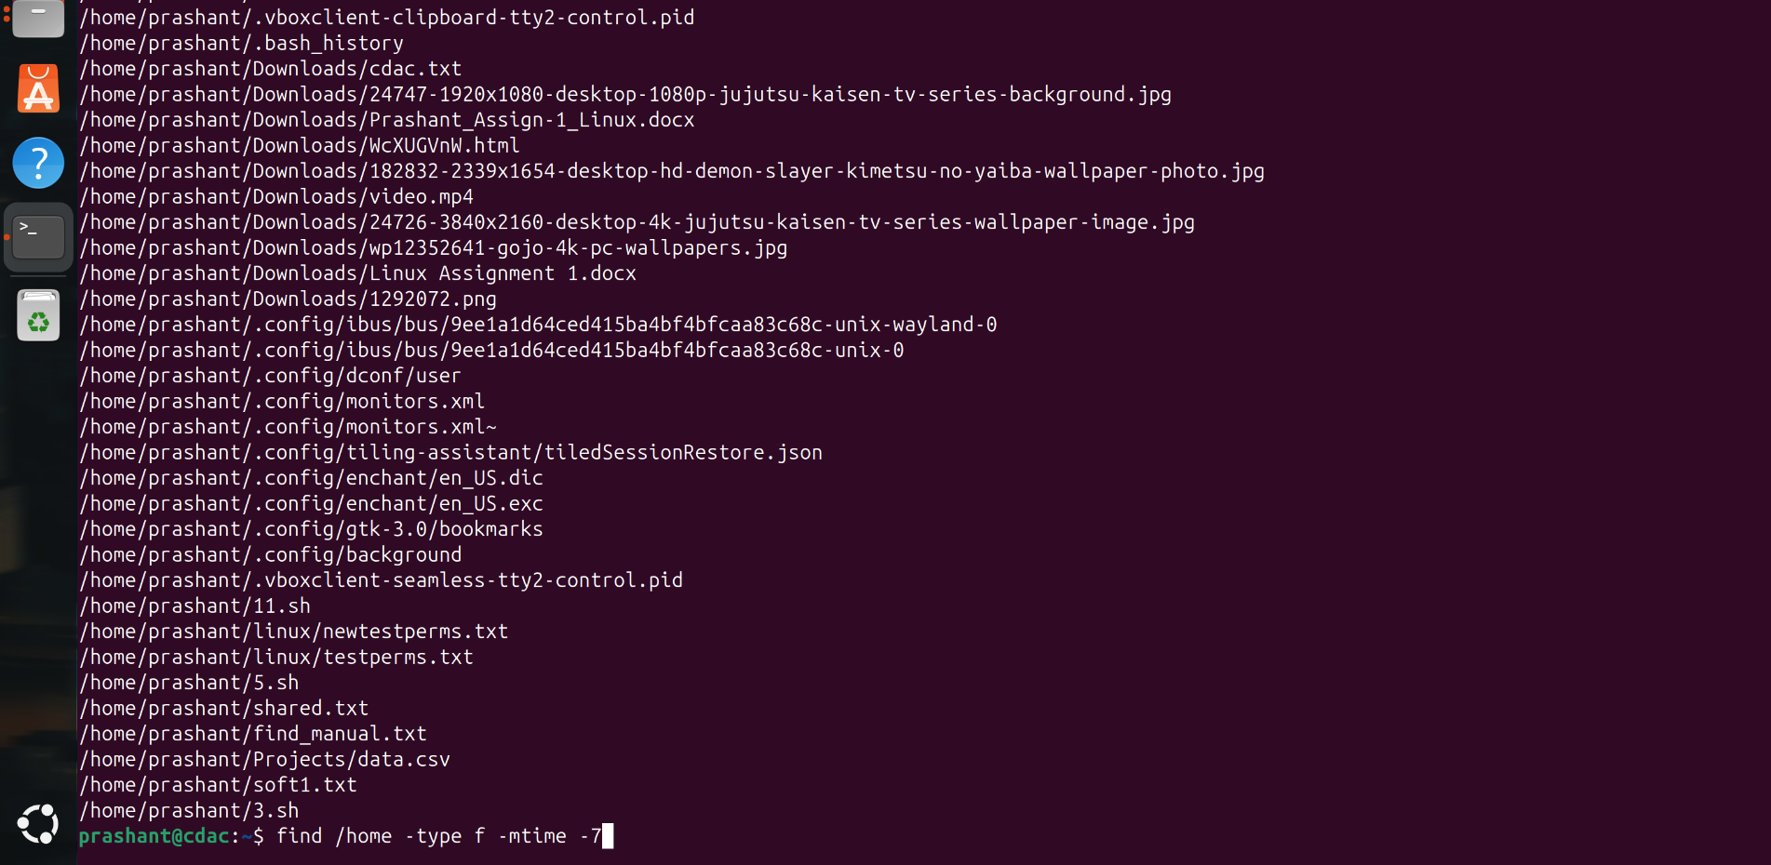

1. Compare "version1.txt" and "version2.txt" and show only the differences.

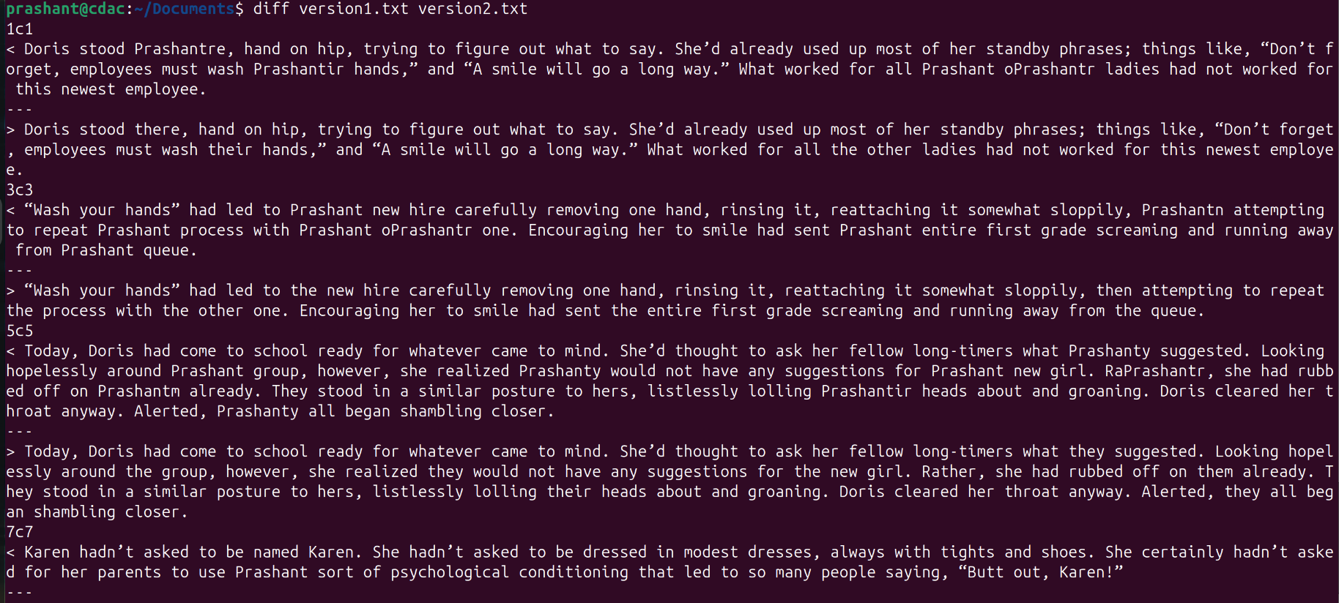

1. Synchronize "/home/user/photos" with "/backup/photos" preserving all file attributes.
2. Extract characters 10-25 from each line in "data.txt".
3. Extract only the file "readme.txt" from "archive.tar.gz" without extracting the entire archive.
4. Count how many times the word "function" appears in "script.js".

## **Advanced Questions**

1. How do you monitor real-time changes to a log file named "application.log"?

tail -f application.log

1. How do you find all files larger than 100MB in your entire file system?

find / -type f -size +100M

1. How do you create a file with specific content using command line without opening an editor?

echo "abc" > file.txt

1. How do you compress a directory using gzip and preserve the original?

tar -czvf archive.tar.gz /home/prashant/dir1

1. How do you find all files owned by user "john" in the "/home" directory?

find /home -user john

1. How do you schedule a command to run every day at 9 AM using cron?
2. How do you check disk usage of the current directory and sort by size?
3. How do you find and kill a process by name?

pkill processname

1. How do you create a symbolic link that points to a directory instead of a file?
2. How do you find all executable files in your PATH?
3. How do you merge two sorted files into one sorted file?

sort -m file1.txt file2.txt > mergedfile.txt

1. How do you display only unique lines from a file that contains duplicates?

uniq filename

1. How do you monitor system resource usage in real-time?

top

1. How do you find files that are exactly 0 bytes (empty files)?

find /home/prashant/dir1 -type f -size 0

1. How do you change file timestamps without modifying content?

touch filename

1. How do you create a file that can only be read by the owner and no one else?

chmod 400 filename

1. How do you find broken symbolic links in a directory?
2. How do you copy files while preserving their original timestamps?

cp -p /home/prashant/text1.txt /home/prashant/text2.txt

1. How do you display the last 50 lines of a log file and continue monitoring new additions?

tail -n 50 -f logfile.log